**Grupo**:

* Pedro Paulo da Silva - 1421422
* Stephanie Fay - 1721631
* Thiago Lages de Alencar - 1721629

tst-avl-02.script

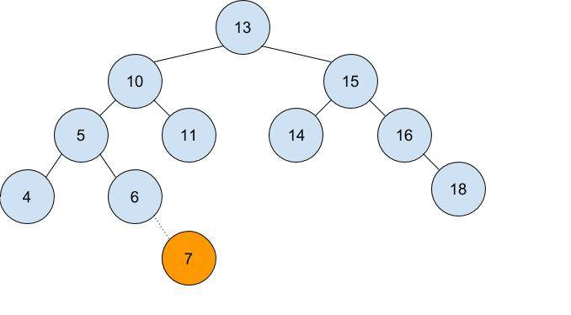

Left right case

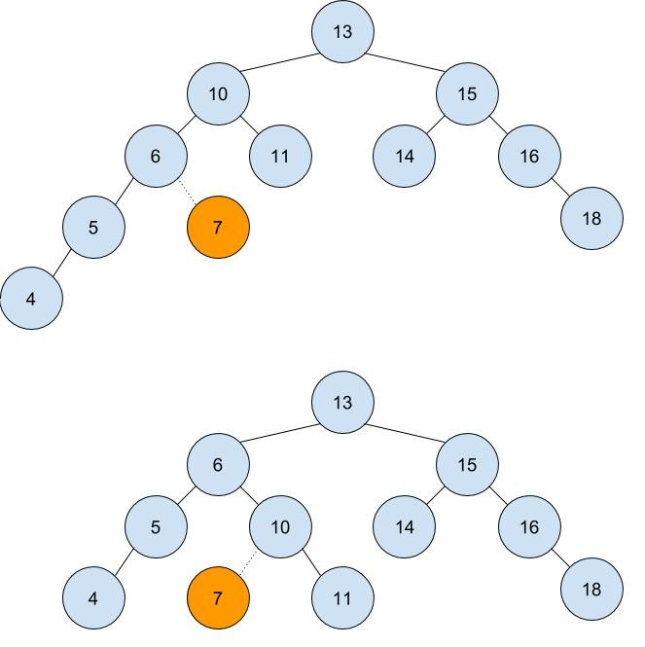

tst-avl-03.script

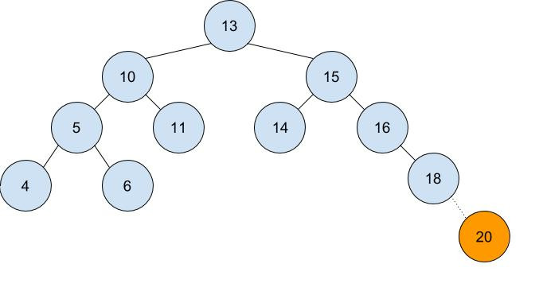

Right right case